Learning Coaches and Students- Whether you’re in Study Island Math or Reading please do the following to get the most out of your Study Island Time.
- Once in Study Island, choose the KCA quiz or Reading practice you need to study for.

2) After you click on your topic, click on the tiny word “lesson” Do not skip this part.

3) A screen will pop up that gives you essential teaching tips and/or formulas to review to help you be successful! This is similar to the “teaching tip” in your yellow booklet found before each “mini-test.” It’s important to not skim over these valuable tools.
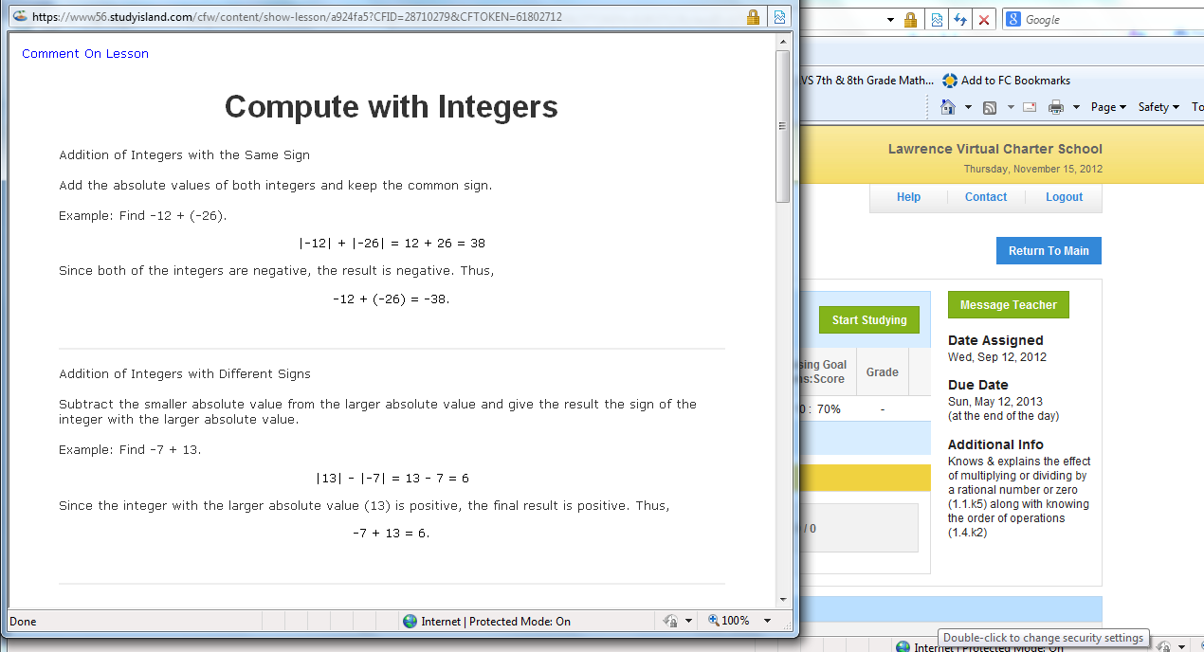
4) After you’ve reviewed the teaching tip material, then you are ready to study. Go for a score of 80% or higher before you take your formative KCA quiz or Study Island Reading quiz.
Remember that once you take a Study Island Reading QUIZ you cannot re-take it. So be sure to study for each Reading topic before taking the quiz.

